Detecting Fraud Apps using Sentiment Analysis

Software Requirements Specification

Version 1.0



Group Id: F25PROJECTE0710 (BC220405393, BC200410422)
Supervisor Name: Tayyaba Sehar

Revision History
Date (dd/mm/yyyy) | Version | Description | Author
11/11/25 | 1.0 | This document will contain the introductory lines regarding my project. It will contain the scope of the project that is being developed. Scope of the project will be explained on the basis of requirements (Functional and Non-Functional) are related to project that will be developed.  A Use Case Diagram is also present in this document. It explains that how a user will act and work on this software. Its complete steps are given in this document and usage scenarios explain that how a Use will work.  At the end, we also explained working methodology and work flow chart. | F25PROJECTE0710 (BC220405393,BC200410422)

Table of Contents

Scope of Project: 4
Functional and non-Functional Requirements: 5
Functional Requirements 5
Non-Functional Requirements 7
Use Case Diagram(s): 8
Usage Scenarios: 8
Admin Use Cases 8
Use Case ID: UC-A1 8
Use Case ID: UC-A2 9
Use Case ID: UC-A3 9
Use Case ID: UC-A4 10
Use Case ID: UC-A5 10
Registered User Use Cases 10
Use Case ID: UC-U1 10
Use Case ID: UC-U2 11
Use Case ID: UC-U3 11
Use Case ID: UC-U4 11
Use Case ID: UC-U5 12
Adopted Methodology 12
VU Process Model 16
Work Plan (Use MS Project to create Schedule/Work Plan) 18

SRS Document

Scope of Project:

The scope of the “Detecting Fraud Apps using Sentiment Analysis” project revolves around creating a robust web-based system aimed at assisting both users and administrators in evaluating the authenticity of mobile applications based on user-generated reviews. With the increasing number of apps available on various online platforms, users often face difficulties in distinguishing genuine applications from fraudulent or misleading ones. This system addresses that challenge by collecting, analyzing, and monitoring reviews submitted by registered users, providing a more reliable and transparent evaluation mechanism. Through sentiment analysis, the system can determine the polarity of comments—positive, negative, or neutral—which enables the admin to make informed decisions about labeling an app as genuine or potentially fraudulent. Additionally, by centralizing app information such as description, category, ratings, and images, the platform provides a comprehensive view of each application, improving accessibility and user experience.
From the administrative perspective, the system provides a suite of tools for managing applications and monitoring user interactions. Admins can add new applications, review feedback, and utilize opinion mining techniques to detect fake or manipulated reviews. The sentiment analysis module acts as a key feature, helping the admin assess the overall reception of an application by aggregating users’ opinions and calculating sentiment scores. By evaluating user comments alongside numerical ratings, the system enhances the decision-making process, allowing the administrator to identify suspicious patterns or inconsistencies in app reviews. Furthermore, the platform maintains a record of registered users and their activities, enabling better user management and tracking of review credibility over time. This structured oversight ensures that the system remains reliable and minimizes the spread of fraudulent applications.
For the end users, the scope of the system focuses on providing a secure and interactive environment for exploring and reviewing mobile applications. Users can register, log in, browse applications across various categories, and view detailed information including ratings and feedback from other users. They are empowered to contribute their own reviews, which are analyzed for sentiment before being displayed, ensuring transparency and authenticity in the feedback process. Additionally, users can provide direct feedback on the system itself, creating a feedback loop that continuously improves the platform’s accuracy and usability. By integrating user participation with administrative oversight and sentiment analysis, the project establishes a comprehensive solution that benefits both users and admins in identifying genuine apps and reducing the prevalence of fraudulent or misleading applications.

Functional and non-Functional Requirements:

Functional Requirements
Functional requirements define what the system must do its core features and operations:
- Application Management
  - The system should allow the admin to add new applications with details such as name, link, description, category, rating, and app image.
  - Admin should be able to update or remove existing applications from the system.
- User Registration and Authentication
  - Users must be able to register by providing necessary details such as name, email, and password.
  - Registered users should be able to login securely using their credentials.
  - Passwords should be securely stored (hashed) to ensure user data protection.
- Application Browsing
  - Users should be able to view the list of available applications grouped by categories.
  - Users can click on any application to see detailed information, including overall ratings and comments from other users.
- Review and Feedback System
  - Users must be able to submit reviews or comments on applications they have used.
  - Users should also be able to provide feedback about the system itself.
  - Each submitted review should be stored and made available for admin analysis.
- Sentiment Analysis / Opinion Mining
  - The system must automatically analyze user reviews to determine the sentiment polarity (positive, negative, neutral) of each comment.
  - The sentiment score should be aggregated to provide an overall rating or reliability score for the application.
- Fraud Detection
  - Admin should be able to view analyzed reviews and sentiment scores to detect fraudulent or suspicious applications.
  - The system should flag reviews or apps that show abnormal sentiment patterns (e.g., fake or overly positive reviews).
- User Management
  - Admin should be able to view the list of registered users and their activities.
  - Admin can take actions if fraudulent activity is detected from users (e.g., multiple fake reviews).
- Notification / Alerts
  - Admin can receive notifications when suspicious activity is detected.
  - Users can receive alerts if their review or feedback is flagged for moderation.

Non-Functional Requirements
Non-functional requirements define how the system performs, rather than what it does. These include performance, usability, and security aspects:
- Performance
  - The system should process user reviews and perform sentiment analysis in real-time or near real-time to provide immediate feedback.
  - It should support multiple simultaneous users without significant delays.
- Scalability
  - The system should be capable of handling an increasing number of users, applications, and reviews over time.
  - Database and server architecture must allow for expansion without major redesign.
- Security
  - User credentials and sensitive data must be encrypted and stored securely.
  - The system should prevent unauthorized access and SQL injection, XSS, and other web-based attacks.
  - Admin functionalities should only be accessible to authorized personnel.
- Reliability and Availability
  - The system should maintain high uptime and be accessible to users at all times.
  - It should handle system failures gracefully, ensuring no data loss occurs during unexpected outages.
- Usability
  - The user interface should be intuitive, allowing both users and admins to perform tasks with minimal training.
  - Navigation should be simple, and application details should be presented clearly.
- Maintainability
  - The system architecture should allow for easy updates, bug fixes, and addition of new features (e.g., new sentiment analysis models).
- Accuracy
  - Sentiment analysis should provide accurate detection of user opinion, minimizing false positives and negatives.
  - Fraud detection algorithms must be tuned to reduce misclassification of genuine apps as fraudulent.
- Compatibility
  - The web application should be compatible with major web browsers (Chrome, Firefox, Edge) and responsive for mobile devices.

Use Case Diagram(s):

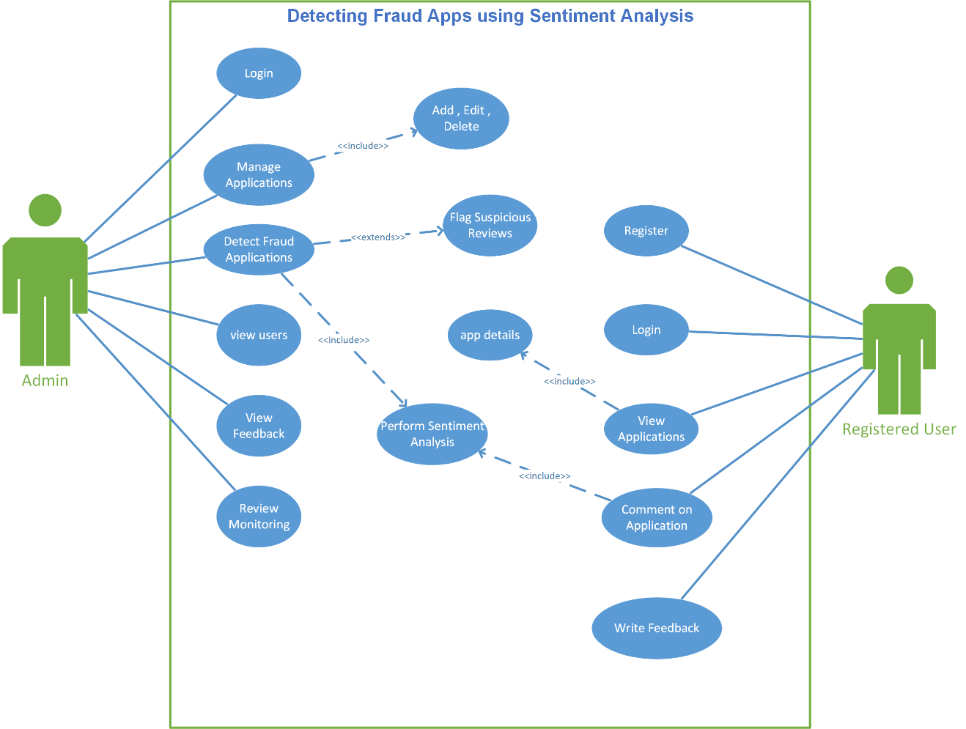

Usage Scenarios:

Admin Use Cases

Use Case ID: UC-A1

Heading | Description
Use Case Title | Add New Application
Actions | Admin fills out application form with name, link, description, category, rating, and image, then submits it.
Description | Allows the admin to add a new mobile application to the system for monitoring and review purposes.
Alternative Paths | If mandatory fields are missing, system shows an error and asks for completion.
Pre-Conditions | Admin must be logged in.
Post-Conditions | Application is stored in the database and visible to users.
Author | F25PROJECTE0710
Exceptions | System fails to store application due to server error; admin receives a notification.

Use Case ID: UC-A2
Heading | Description
Use Case Title | Detect Fraud Applications
Actions | Admin selects an app, reviews user comments and sentiment scores, and marks the app as genuine or fraudulent.
Description | Admin evaluates applications to detect fake or misleading apps using sentiment analysis and review monitoring.
Alternative Paths | If user reviews are insufficient, admin may request more data or user feedback before deciding.
Pre-Conditions | Admin must be logged in; app must exist in the system.
Post-Conditions | App is classified as genuine or fraudulent.
Author | F25PROJECTE0710
Exceptions | System fails to fetch reviews; admin cannot analyze app.

Use Case ID: UC-A3
Heading | Description
Use Case Title | View Users
Actions | Admin navigates to the user management panel to see registered users and their details.
Description | Admin can view all registered users and track their activity in the system.
Alternative Paths | If database is empty, system shows “No users available.”
Pre-Conditions | Admin must be logged in.
Post-Conditions | User list is displayed on the admin panel.
Author | F25PROJECTE0710
Exceptions | Server error prevents fetching user data.

Use Case ID: UC-A4
Heading | Description
Use Case Title | View Feedback
Actions | Admin accesses the feedback panel to read user comments about the system.
Description | Admin can read user feedback submitted about system functionality and usability.
Alternative Paths | If no feedback exists, system shows “No feedback available.”
Pre-Conditions | Admin must be logged in.
Post-Conditions | Feedback list is displayed for review.
Author | F25PROJECTE0710
Exceptions | System fails to retrieve feedback from database.

Use Case ID: UC-A5
Heading | Description
Use Case Title | Review Monitoring (Opinion Mining)
Actions | Admin triggers sentiment analysis on user reviews; system ranks apps by sentiment score.
Description | Admin uses opinion mining to evaluate reviews for authenticity and calculate sentiment-based app scores.
Alternative Paths | If sentiment analysis fails, admin can manually review user comments.
Pre-Conditions | Admin must be logged in; app must have user reviews.
Post-Conditions | Applications are ranked; suspicious reviews flagged.
Author | F25PROJECTE0710
Exceptions | Sentiment analysis model fails; system logs error and notifies admin.

Registered User Use Cases

Use Case ID: UC-U1

Heading | Description
Use Case Title | Register / Login
Actions | User fills registration form or logs in with credentials to access the system.
Description | Allows users to create an account or log in to access apps and post reviews.
Alternative Paths | If credentials are invalid, system shows an error.
Pre-Conditions | User must not be currently logged in (for registration) or must have an account (for login).
Post-Conditions | User account is created or user successfully logged in.
Author | F25PROJECTE0710
Exceptions | System fails to save new user due to server or database error.

Use Case ID: UC-U2
Heading | Description
Use Case Title | View Applications
Actions | User navigates the application list to browse available apps by category.
Description | Enables users to explore mobile applications in the system.
Alternative Paths | If no applications exist, system shows “No applications available.”
Pre-Conditions | User must be logged in.
Post-Conditions | Application list displayed successfully.
Author | F25PROJECTE0710
Exceptions | Database fetch error prevents displaying apps.

Use Case ID: UC-U3
Heading | Description
Use Case Title | View Application Details
Actions | User clicks an application to view its description, ratings, comments, and download link.
Description | Allows users to see detailed information and feedback about an application.
Alternative Paths | If application details are missing, system shows partial information.
Pre-Conditions | User must be logged in; selected app must exist.
Post-Conditions | App details are displayed.
Author | F25PROJECTE0710
Exceptions | Application data cannot be retrieved; system shows error.

Use Case ID: UC-U4
Heading | Description
Use Case Title | Comment on Application
Actions | User writes and submits a review or rating for an application.
Description | Allows users to provide feedback on apps, which will be analyzed for sentiment.
Alternative Paths | If comment is empty, system asks for valid input.
Pre-Conditions | User must be logged in; application must exist.
Post-Conditions | Comment is saved and analyzed for sentiment.
Author | F25PROJECTE0710
Exceptions | System fails to save comment; user is notified.

Use Case ID: UC-U5
Heading | Description
Use Case Title | Write Feedback
Actions | User writes feedback about the system and submits it to admin.
Description | Allows users to provide suggestions or report issues about the system.
Alternative Paths | If feedback is empty, system requests valid input.
Pre-Conditions | User must be logged in.
Post-Conditions | Feedback is saved in the system for admin review.
Author | F25PROJECTE0710
Exceptions | System fails to store feedback due to server error.

Adopted Methodology

Available Methodologies:

There are the following methodologies:
• Build-and-fix model
• Waterfall model
• Rapid prototyping model
• Incremental model
• Extreme programming
• Synchronize-and-stabilize model
• Spiral model
• Object-oriented life-cycle models

CHOSEN METHODOLOGY:

Different methodologies and models are used by the people according to their work and planning. We will use “VU process model” It is combination of two models Water Fall and Spiral methodologies.

Waterfall Model:

This model is also known as linear sequential model. This model is depicted in the following diagram.

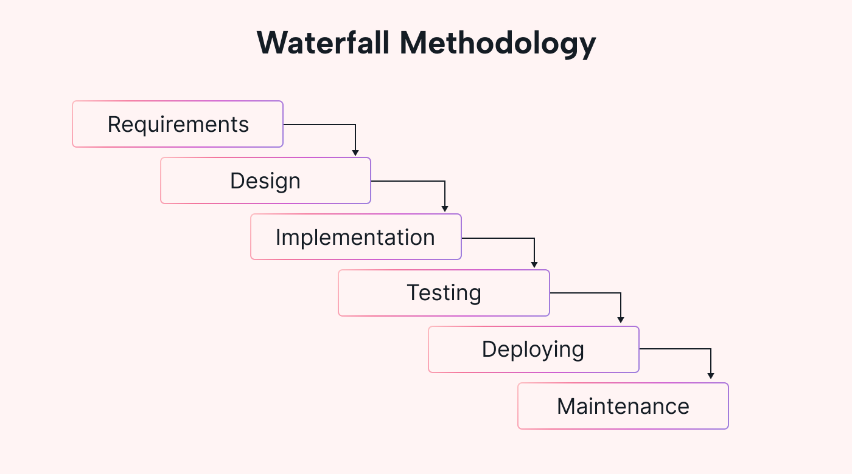

It suggests a systematic, sequential approach to software development that begins at the system level and progresses through the analysis, design, coding, testing, and maintenance.
Real projects rarely follow the sequential flow that the model proposes. In general these phases overlap and feed information to each other. Hence there should be an element of iteration and feedback. A mistake caught any stage should be referred back to the source and all the subsequent stages need to be revisited and corresponding documents should be updated accordingly. This feedback path is shown in the following diagram.

Conclusion:
The Waterfall Model is a documentation-driven model. It therefore generates complete and comprehensive documentation and hence makes the maintenance task much easier. It however suffers from the fact that the client feedback is received when the product is finally delivered and hence any errors in the requirement specification are not discovered until the product is sent to the client after completion. This therefore has major time and cost related consequences.

Spiral Model:

This model was developed by Barry Boehm. The main idea of this model is to avert risk as there is always an element of risk in development of software. For example, key personnel may resign at a critical juncture, the manufacturer of the software development may go bankrupt, etc.

Rapid Prototype
Specification
Design
Implementation
Risk Analysis
Verify

In its simplified form, the Spiral Model is Waterfall model plus risk analysis. In this case each stage is preceded by identification of alternatives and risk analysis and is then followed by evaluation and planning for the next phase. If risks cannot be resolved, project is immediately terminated.

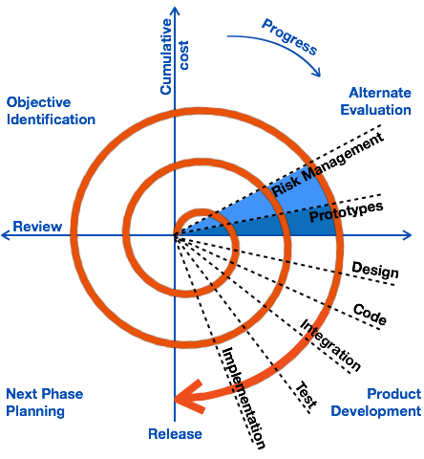

Conclusion:

As can be seen, a Spiral Model has two dimensions. Radial dimension represents the cumulative cost to date and the angular dimension represents the progress through the spiral. Each phase begins by determining objectives of that phase and at each phase a new process model may be followed. The main strength of the Spiral Model comes from the fact that it is very sensitive to the risk. Because of the spiral nature of development, it is easy to judge how much to test and there is no distinction between development and maintenance. It however can only be used for large-scale software development and that too for internal (in-house) software only.

VU Process Model which is the combination of Waterfall and Spiral model. In this model each stage of waterfall is preceded by identification of alternatives and risk analysis and is then followed by evaluation and planning for the next phase.

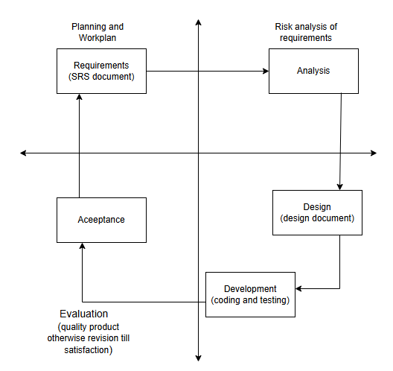

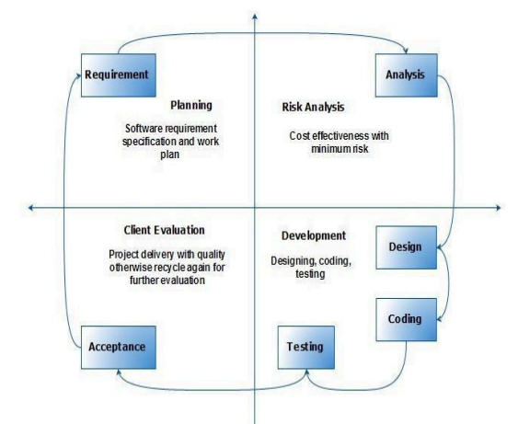

Reasons for choosing the Methodology

It derives the benefits of predictability from the milestone-based planning of the waterfall model, as well as the benefits of feedback and creativity from the spiral model.

- The VU Process Model is a documentation-driven model. It therefore generates complete and comprehensive documentation and hence makes the maintenance task much easier because the feedback of user must fulfil on each phase of development.
- .VU Process Model is heavily dependent on risk analysis and evaluation in each phase.
- Progress Tracking and Risk management is easy in this process.
- Project can be divided into small units and thus the Object-Oriented Approach for web based application can easily be implemented.
- Iterations are easily manageable.
- Application Quality Assurance can easily be managed by testing the developed modules individually.
- The modules or prototypes which are successfully developed can be implemented independently and can be easily integrated.
- The deadline for the given project is good enough to be build. So we can easily choose selected methodology to work upon.

Work Plan (Use MS Project to create Schedule/Work Plan)

